



Volume 23 Sponsors of the Child and Adult Care Food Program August 2009
Issue 11 Blake Stanford, President Brenda Baldwin, Program Director
Liz Curtis, Compliance Officer Martin North, Website/MM Kids Specialist Lindsey Seybold, Editor
In this Issue:
- Workshops
- Annual Training
- New July Rates!
- To Keep You Posted
- Provider’s Spotlight
- Health and Sanitation
- Protein (Pt 2 of 5)
- New Crafts and Recipes ☺
- August Calendar
Tip of the Month:
For all providers using all paper forms!
Don’t know a child’s ID number?
Are you unsure which child ID numbers are free for new children?
Have you misplaced your current month’s CIF?
Call the office and we will mail you a new CIF ASAP!

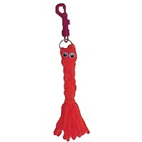



Workshops in August

Saturday, August 1, 2009
Houston, TX 10:15a-1:30p
Parker William Branch Library
Meeting Room F in Annex across parking lot
10851 Scarsdale at Beamer Rd
10:15-11:30a ~ review/updates CACFP
11:30a-12:30p ~ required forms training
12:45-1:30p ~ mandatory annual training
Directions: 281-484-2036 www.hcpl.lib.tx.us
Registration: 281-556-0076 Dianne
Bring 10-12 servings of your best finger foods that you serve. I will have water, tea, plates, etc. Let’s share recipes and experiences!

Saturday, August 22, 2009
Houston, TX 9a -1:30p
Scenic Woods Regional Library
10677 Homestead Rd 77016
10-11:30a ~review/updates CACFP
11:30a-12:30p ~required forms training
12:45-1:30p ~mandatory annual training
Directions: 832-393-2030
Registration: 281-556-0076 Dianne
Bring 10-12 servings of your best finger foods that you serve. I will have water, tea, plates, etc. Let’s share recipes and experiences!

Back to school craft!

Backpack Buddy
For good luck this school year, clip a buddy to your back pack and bring it with you on your first day of school ☺
Supplies
Neon Wireless Chenille
Plastic Clips
Wiggle Eyes -- 10mm
Low Temp Glue Gun, or Tacky Glue
Scissors
Instructions
Cut a 6 two yard pieces of wireless chenille. Thread all six pieces to the middle through the ring on a plastic clip. Gather all strands together and split into 3 bunches. Braid. Cut a small piece of wireless chenille to tie off, double knotting tightly around the bottom of the braid. Trim ends. Glue on wiggle eyes.
*freekidscrafts.com
c

Online Training

Federally required mandatory training is available on our website at www.swhuman.org. If you cannot make it to one of our free workshops there is a Self-Instructional Training Packet and Civil Rights Guide that you can do at home. Go to the website, click on training, download the materials, take the tests and mail them in along with a completed certificate. We only need the signed certificate and tests for our file, not the whole packet. Please feel free to call the office with any questions 1-800-369-9082.Your coordinator might have extra packets or printed tests so ask at your next visit!

MOVING?

When you move to a new address you must be re-inspected by childcare licensing and given a new certificate before you can be reimbursed for any meals at your new home. Please contact our office to let us know when you move and send us a copy of your new certificate as soon as you get it! Good luck with the move!
New Pay Rates for July Claims!!

Breakfast
Tier 1: $1.19
Tier 2: $.44

Lunch/Dinner
Tier 1: $2.21
Tier 2: $1.33

Snack
Tier 1: $.66
Tier 2: $.18

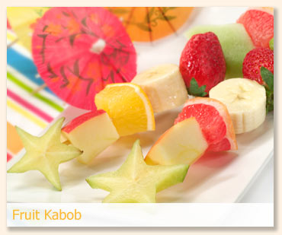







Mystery Provider
Each month in this newsletter we put the provider ID of one MYSTERY PROVIDER. The Mystery Provider wins a fun children’s book to share with their kiddos. If you find your ID somewhere in the newsletter call the office at 1-800-369-9082 and claim your prize!

Kids' Kabobs

- Using toothpicks as skewers, thread on fruit and cheese of your choice.
- Try using pineapple, strawberries and chunks of mozzarella. Or perhaps grapes, cheddar and apples.
- The choices are endless so let the kids brainstorm and make some suggestions, too.
- Make a big batch and store them in a plastic container in the fridge.
- Use seasonal or canned fruit and big chunks of cheese so you can cube them down to size.
- These are a perfect food item to play “pretend” kitchen or even “pretend” grilling!
**If the children are very young, watch the toothpicks**

To keep you posted . . . . .
To all providers:
- Please do not ever staple anything that you send to us. Write your name and provider ID at the top of every page for proper filing.
- Remember… Potatoes must be claimed as a vegetable only and are NOT reimbursable as a bread/bread alternative.
To all providers using MM Kids Online
- Always download MM Kids Online from our website swhuman.org. Never pay for it! This program is free as long as you are claiming with Southwest ☺

Answers to July’s quiz
1. true
2. calories, nutrients
3. false
4. eggs, nuts, beans
5. false
6. nutrients, fiber
7. true
8. unsaturated
9. true
10. soluble, insoluble
246-0170
Health and Sanitation Tips
(Part 2 of 4)
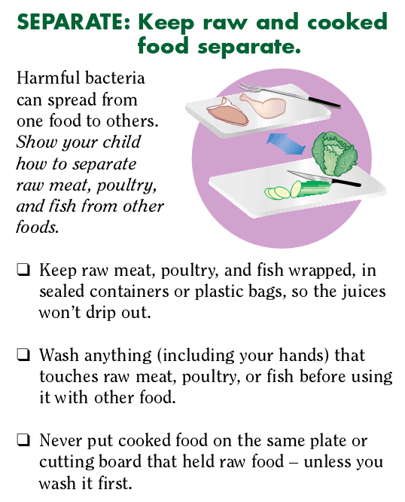
**Spotlight Provider**
Jennifer Baker operates her excellent daycare with her mother while they care for infants and young toddlers. She serves yummy homemade foods while keeping a calm atmosphere. Such an incredible feat with the little ones! Beautiful job!
Staci Evans also provides happy mealtimes with her daycare children. Always encouraging her kids to try new foods, Staci patiently converted one young child who ate no fruits or vegetables to actually liking them! She loves to serve tortilla wraps which the kids fondly call “pinwheels.” Way to go Staci!
Both of our spotlight providers this month are using Minute Menu Kids Online to keep their records! Contact your Program Coordinator or the Austin office to get started on this great online program.
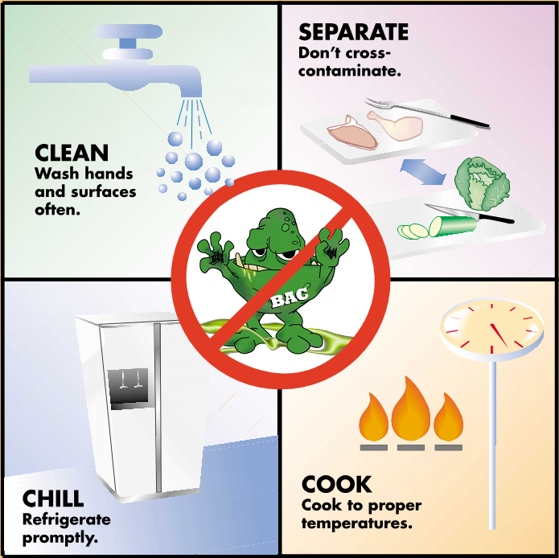

Nutrition Basics: Protein (Part 2 of 5)
Did you know?
Many people think of nuts as just another junk food snack. In reality, nuts are excellent sources of protein and other healthful nutrients. Raw almonds or walnuts pack in the most vitamins as well as protein. Older children can dip them in honey or yogurt for a great snack! Or try them chopped and sprinkled on cereal!
Yum!

Introduction
Around the world, millions of people don't get enough protein. Protein malnutrition leads to the condition known as kwashiorkor. Lack of protein can cause growth failure, loss of muscle mass, decreased immunity, weakening of the heart and respiratory system, and death.



In the United States and other developed countries, getting the minimum daily requirement of protein is easy. Cereal with milk for breakfast, a peanut butter and jelly sandwich for lunch, and a piece of fish with a side of beans for dinner adds up to about 70 grams of protein, plenty for the average adult.
Nutrition in Depth: What Is Protein?
Protein is found throughout the body—in muscle, bone, skin, hair, and virtually every other body part or tissue. It makes up the enzymes that power many chemical reactions and the hemoglobin that carries oxygen in your blood. At least 10,000 different proteins make you what you are and keep you that way.
Twenty or so basic building blocks, called amino acids, provide the raw material for all proteins. Following genetic instructions, the body strings together amino acids. Some genes call for short chains of amino acids, others are blueprints for long chains that fold, origami-like, into intricate, three-dimensional structures.


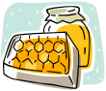


Because the body doesn't store amino acids, as it does fats or carbohydrates, it needs a daily supply of amino acids to make new protein.

All Protein Isn't Alike
Some of the protein you eat contains all the amino acids needed to build new proteins. This kind is called complete protein. Animal sources of protein tend to be complete. Other protein sources lack one or more "essential" amino acids—that is, amino acids that the body can't make from scratch or create by modifying another amino acid. Called incomplete proteins, these usually come from fruits, vegetables, grains, and nuts.


To get all the amino acids needed to make new protein—and thus to keep the body's systems in good shape—people who don't eat meat, fish, poultry, eggs, or dairy products should eat a variety of protein-containing foods each day. Often classic combinations of foods, like beans and rice or peanut butter and whole grain bread, will together contain all the essential amino acids needed by the body.

Recommendations for Protein Intake
- Get a good mix of proteins. Almost any reasonable diet will give you enough protein each day. Eating a variety of foods will ensure that you get all of the amino acids you need.
- Pay attention to the protein package. You rarely eat straight protein. Some protein comes packaged with healthful fiber and micronutrients, such as beans, nuts, and whole grains. Some protein comes packaged with lots of unhealthy fat, like when you eat marbled beef or drink whole milk. Fish and poultry are the best choices for meat eaters; if you are partial to red meat, such as beef, pork or lamb, steer yourself toward the leanest cuts, and make it only an occasional part of your diet. If you like dairy products, skim or low-fat versions are healthier choices.
- Balance carbohydrates and protein. Cutting back on highly processed carbohydrates and increasing protein intake improves levels of blood triglycerides and HDL, and so may reduce your chances of having a heart attack, stroke, or other form of cardiovascular disease. It may also make you feel full longer, and stave off hunger pangs.
** based on an article from: hsph.harvard.edu/nutritionsource/what-should-you-eat/protein-full-story/index.html
1
Houston Workshop
2  Friendship Day | 3  Send in Claim! | 4 | 5 | 6 |   7 | 8
9 | 10 | 11 |   12 | 13 | 14 | 15
16 | 17 | 18 | 19  National Aviation Day | 20 | 21 | 22  Houston Workshop
23 | 24 | 25 | 26  Women’s Equality Day |   27 | 28 | 29
30 | 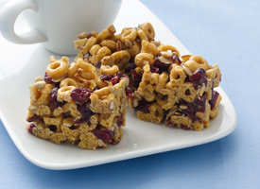  31  One more fun  Summer craft ☺  - Sun Prints   Just an hour in the sun at noon will fade construction paper to leave behind decorative "prints" and a lesson in the power of Mother Nature.  Supplies  - A Sunny Day  - Construction Paper  (Darker Colors will Work the Best)  - Objects from Nature or around  the House(Flatter items Work Best)  Instructions  Lay construction paper outside in the sun. Arrange items on the paper so their silhouettes will look nice. Wait about an hour and remove the items. You will see the paper has faded around the objects. Be sure not to be tempted to peek ahead of time, because it will be almost impossible to position the items exactly the way they were.  *freekidscrafts.com
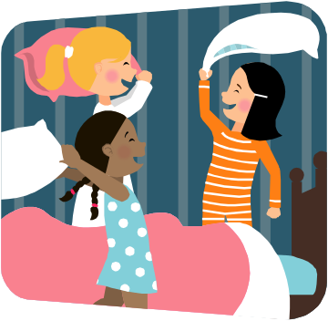
August

Homemade Cereal Bars

Ingredients:
- 1/4 cup granulated sugar
- 1/4 cup honey
- 1/4 peanutbutter-any style
- 2-3 cups cheerios or any whole grain or high fiber cereal
- A sprinkle of dried fruits, nuts, or any other creative mix-in
- vegetable spray for loaf pan

Directions:
- In a medium saucepan, over medium heat melt the sugar and honey together until the sugar is dissolved.
- Stir in the peanut butter until smooth.
- Fold in the cereal and mix-ins; put into a greased loaf pan.
- Chill for one hour, slice into bars.
- Store in a plastic bag in the refrigerator for easy snacking access.

Serving Suggestions:
- With dried fruits/nuts on top as a snack bar substitute.
- With a glass of milk for dunking. Add a serving of fresh fruit to make a complete breakfast.
- 246-0048 *recipes.sparkpeople.com



